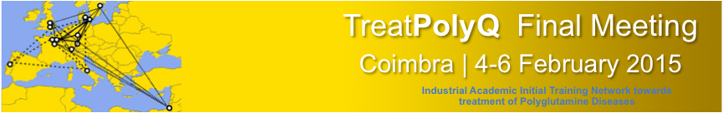

Wednesday 4 February - 11:30
Museum of Science – University of Coimbra
Key Note Conference
The Ubiquitin Proteolytic System
From Basic Mechanisms through Human Diseases and into Drug Targeting
Aaron Ciechanover
Nobel Prize in Chemistry in 2004,
Technion
Israel Institute of Technology

Thursday 5 February - 11:30
Museum of Science – University of Coimbra
Key Note Conference
Proteostasis Networks and Stress Responses
in Aging and Neurodegenerative Disease
Richard Morimoto
Bill and Gayle Cook Professor of Biology
Department of Molecular Biosciences
Northwestern University, EUA

Museum of Science – University of Coimbra
Thursday 5 February - 14:30
Conference
Targeting the intracellular localization of Ataxin-3
as treatment strategy for SCA3
Thorsten Schmidt
University of Tuebingen, Germany
G

Museum of Science – University of Coimbra
Thursday 5 February - 15:00
Key Note Conference
Ubiquitin signaling pathways in neurodegeneration:
insights from polyglutamine disorders

Henry Paulson
Department of Neurology
University of Michigan, EUA

Museum of Science – University of Coimbra
Friday 6 February - 9:00
Conference
Critical roles for neurodegeneration-associated proteins
in the DNA damage response
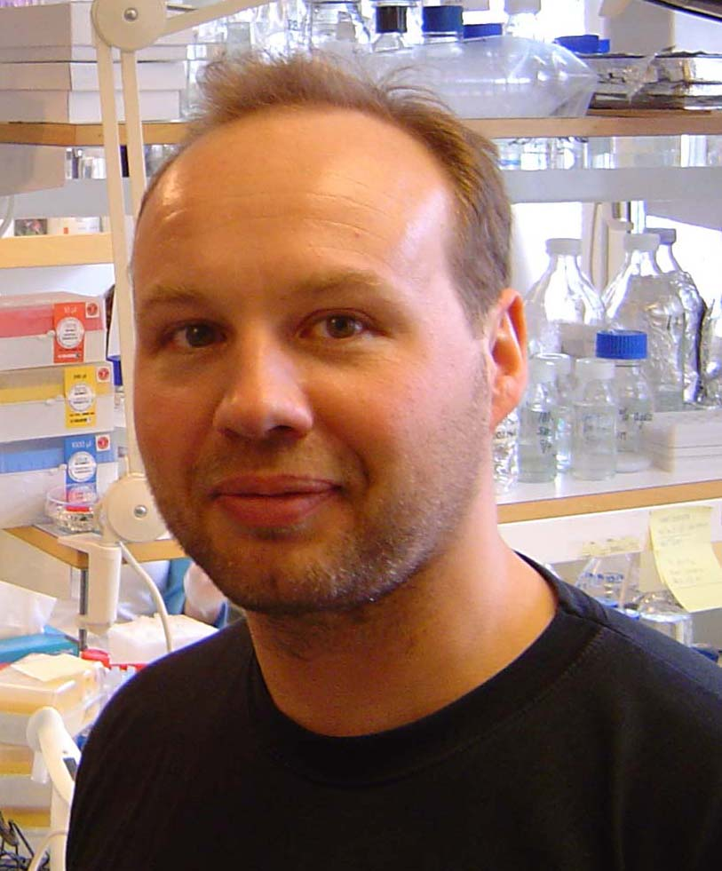
Nico Dantuma
Karolinska Institut, Sweden

Museum of Science – University of Coimbra
Friday 6 February - 9:30
Conference
Prion-like propagation of protein assemblies
in neurodegenerative diseases
Ronald Melki
Laboratory of Enzymology and
Structural Biochemistry - CNRS
France

Museum of Science – University of Coimbra
Friday 6 February - 10:00
Conference
Using zebrafish as a model to understand the role of autophagy in neurodegeneration
Angeleen Fleming
Cambridge Institute for Medical Research
United Kingdom

Museum of Science – University of Coimbra
Friday 6 February - 11:00
Title to be announced
Andreas Muhs

Museum of Science – University of Coimbra
Friday 6 February - 11:30
Conference
Machado-Joseph disease: from gene silencing to protein clearance
Luis Pereira de Almeida
CNC – Center for Neurosciences and Cell Biology
University of Coimbra, Portugal

Museum of Science – University of Coimbra
Friday 6 February - 12:00
Conference
Insights into the molecular basis of Huntington’s disease
and the validation of therapeutic targets
Gillian Bates
Kings College of London, UK

Museum of Science – University of Coimbra
Friday 6 February - 14:30
Conference
Time controlled and tissue specific Drosophila models
of human neurodegenerative diseases
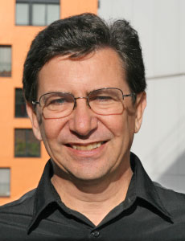
Hervé Tricoire
Université Paris-Diderot

Museum of Science – University of Coimbra
Friday 6 February - 15:00
Conference
Molecular and structural abnormalities of striatal projection neurons
in Parkinson´s and Huntington´s disease
Angela Cenci-Nilsson
Lund University, Sweden

Museum of Science – University of Coimbra
Friday 6 February - 15:30
Conference
Immunotherapy with alpha-synuclein specific antibodies
Karina Fog
H. Lundbeck, Denmark

